CS201 - Fall 2017-2018 - Sabancı University
Homework #3 – Intelligent Travelling Robot
Due October 25, 2015, Wednesday, 19:00 (Sharp Deadline)

Description

In this homework, you will write a robot application that uses the robot class discussed in the lecture. This class is also described in a document called “RobotWorld.pdf” that is in the robot.zip package available in CS201 website. All the material needed for the robot class is also in this robot.zip package. Please examine the RobotWorld.pdf file and the example programs. You will practice on the robot class during recitations this week. In order to do this homework, it is to your benefit to attend recitations because Robot World is something quite different considering what you have learned until now.

The C++ program that you are going to write will create a robot in an input location. Then, this robot will visit three target cells. These target cells are fixed and are at the following coordinates: target 1 is cell (8, 6); target 2 is cell (2, 3); target 3 is cell (4, 10). The robot moves intelligently so that first it should go to the closest target cell. After that, the robot should go to other two target cells in a predefined order as mentioned below.
- if the closest cell is the target 1, then after target 1, the robot should go to target 3 and then to target 2
- if the closest cell is the target 2, then after target 2, the robot should go to target 3 and then to target 1
- if the closest cell is the target 3, then after target 3, the robot should go to target 1 and then to target 2

After all the movements (i.e. at the end of the program), the robot should stay facing east.

The initial coordinates of the travelling robot will be entered as inputs by the user. The coordinates of this robot must be non-negative; otherwise, your program should display an appropriate error message and should not even create the robot (and of course no robot movements will be performed). Other than this rule, you cannot make any assumption on the position of the robot relative to the targets.

Since you will need to determine the "closest" target cell, here we need to make a definition of "distance" between two cells. In this homework, distance between two cells with given coordinates (x₁, y₁) and (x₂, y₂) is defined as the total number of horizontal and vertical steps needed to reach from one cell to the other; NOT as the length of the hypotenuse. In other words, the distance is calculated using the following formula:
| x₁ - x₂ | + | y₁ - y₂ |

In order to determine the closest target cell, first you have to calculate the distances between the robot's initial location and each the target cell (you may a write a non-void function for this calculation and call it three times). The closest target cell is the one with the minimum distance. A special condition occurs when more than one target cell are at equal distance to the initial location of the travelling robot and this distance is the minimum one. In such a case, your robot may choose any of these closest cells to start with. In other words, there is no rule for tie-break.

The initial orientation (the direction that the robot faces when created) is NOT an input. The default orientation is east and the robot is to be created facing east. The default color of the robots after creation is yellow. In this homework, the color of the traveling robot is also yellow at the beginning. However, after moving to the closest target, its color must be changed to blue.

The final direction of the robot after all movements have been completed must be east.

The original location of the robot and the closest target cell may or may not be on the same horizontal or vertical line. If they are on the same line, in order to reach this closest target, the robot will make one movement (horizontal or vertical). However if these two cells are not on the same line, then the robot will make both vertical and horizontal movements to reach the closest target. Similarly, both horizontal and vertical movements are needed for the travels between other targets. Here, we do not set a particular rule about the order of horizontal or vertical movements. Your robot could either move first horizontally then vertically or first vertically then horizontally. This is up to the programmer (i.e. yourself). The only rule is that all targets must be visited starting with the closest one and going in a predefined order, as mentioned above (on the first page of this document).

For your convenience, we provide a robot world file called "world.rw” in the same zip package as this document. In this rw file, the target cells are marked as 1, 2 and 3. You may run your program on this robot world. Although the program should also work on an empty robot world, running it on world.rw would help you to check the correctness of your program since you visualize the targets on the robot world. To open world.rw file, first copy it in your local folder. After that execute your program and use File → Open menu item of the robot world.

IMPORTANT!

If your code does not compile, you will get zero. Please be careful about this and double check your code before submission.

Please examine the following screenshots for some examples. Here please remark that following screenshots show only some example cases; not all possible cases for relative positions of the travelling robot with respect to the target cells. Relative positions of the travelling robot may be any combination depending on the input coordinates. Your program should work properly in all possible cases.

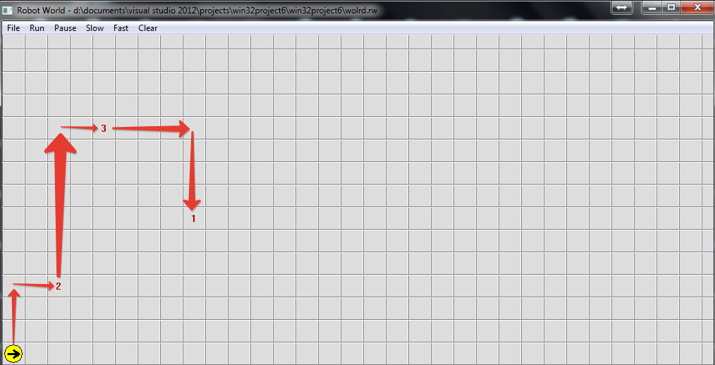

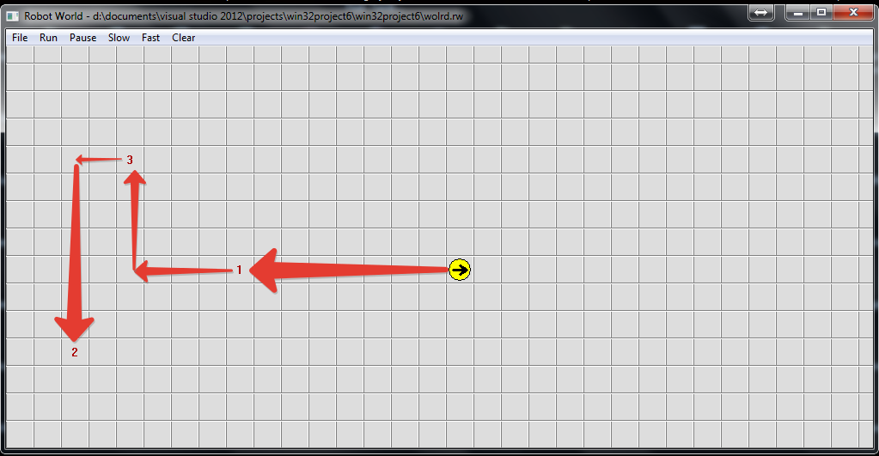
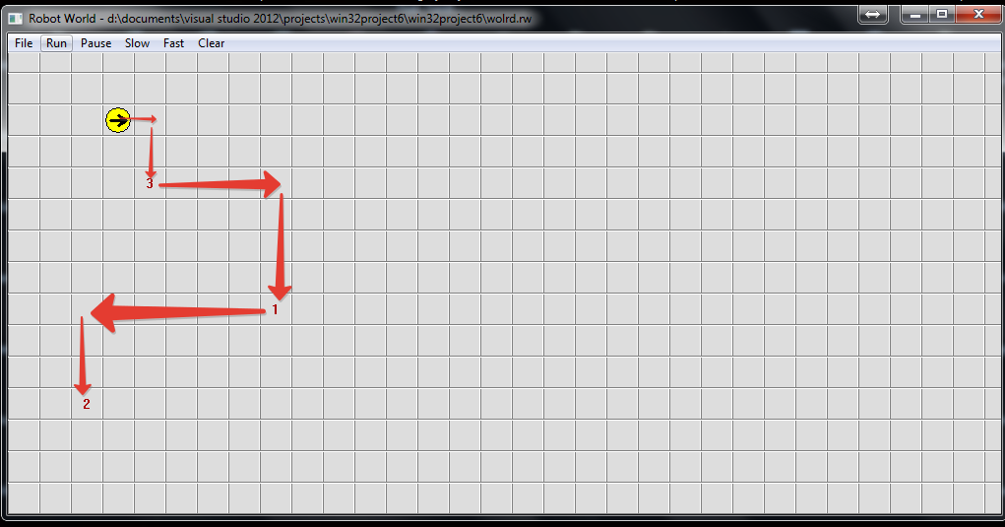

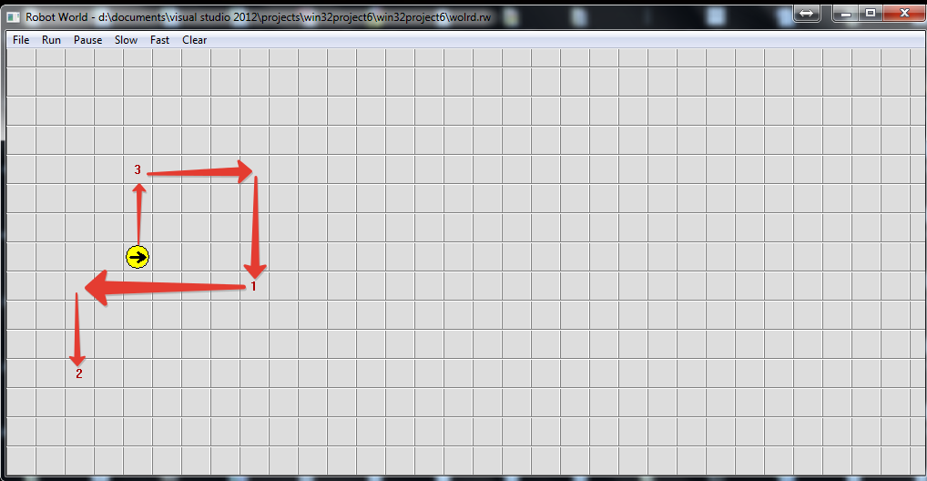

Input Entry and Input Check

Your program should first input the x coordinate of the travelling robot with an appropriate prompt. If this value is negative, then your program should display an error message specifying that x coordinate is entered as wrong and your program should come to the end without even asking and reading the y coordinate (and of course without creating and moving the robot). If the x coordinate is entered correctly, then your program should input the y coordinate with an appropriate prompt. If the y coordinate is also entered correctly, then the robot must be created at this input coordinates and the program should proceed. However, if a negative value is entered as the y coordinate, then your program should display an error message specifying that y coordinate is entered as wrong and your program should come to the end without even creating and moving the robot.

Input and Output in Robot Environment

You cannot use cin and cout for input and output in robot environment. The reasons for this fact and remedies are explained in the RobotWorld.pdf file. Please read this document carefully and examine the example program given in recitation materials this week in order to understand the I/O functionality that you are going to use in this homework.

Use of Functions and Other Rules

Unlike the second homework, we will not specify any functions here. But you are expected to use functions to avoid code duplication and to improve the modularity of your program. If your main function or any user-defined function is too long and if you do everything in main or in another user-defined function, your grade may be lowered.

And please do not write everything in main and then try to split the task into some functions just to have some functions other than main. This is totally against the idea of functional design and nothing but a dirty trick to get some poınts. Instead please design your program by considering necessary functions at the beginning.

Try to use parametric functions and avoid inputs in functions. Do NOT use any global variables (variables defined outside the functions) to avoid parameter use.

As in the previous homework, no abrupt program termination is allowed in the middle of the program! The program flow should continue until the end of the main function.

Creating robots in user-defined functions may be problematic in this homework. Thus, please create your robots only in main function; and pass these robots as parameters to your user-defined function whenever needed (Do not forget to put & while specifying robot parameters of the functions). Also remember that any robot that is created in a compound block can only be referred in that block, not outside, due to scope rules. Please check out the lecture notes for details.

Demo Application

Due to interactive feature of this homework, we are not able to provide sample outputs, but we provide an executable file that can be run to understand how your program should work. We have already written the program for this homework and the corresponding executable file (hw3.exe) is given to you within the same zip package of this homework document.

General Rules and Guidelines about Homeworks

The following rules and guidelines will be applicable to all homeworks, unless otherwise noted.

How to get help?

You may ask questions to TAs (Teaching Assistants) of CS201. Office hours of TAs are at the class website. Recitations will partially be dedicated to clarifying the issues related to homework, so it is to your benefit to attend recitations.

Moreover, in the recitations for the first homework, there will be a demonstration on how to prepare homework for submission and how to submit it to SUCourse. This process is not so straightforward. We have experienced several unsuccessful submissions in the previous years. Therefore, we strongly recommend you attend this demo.

What and Where to Submit

Please see the detailed instructions below/in the next page. The submission steps will get natural/easy for later homeworks.

Grading and Objections

Careful about the semi-automatic grading: Your programs will be graded using a semi-automated system. Therefore, you should follow the guidelines about input and output order; moreover, you should also use same prompts as given in the Sample Runs. Otherwise semi-automated grading process will fail for your homework, and you may get a zero, or in the best scenario you will lose points.

Grading:

- Late penalty is 10% off the full grade and only one late day is allowed.
- Having a correct program is necessary, but not sufficient to get the full grade. Comments, indentation, meaningful and understandable identifier names, informative introduction and prompts, and especially proper use of required functions, unnecessarily long program (which is bad) and unnecessary code duplications (which is also bad) will also affect your grade.
- Please submit your own work only (even if it is not working). It is really easy to find out “similar” programs!
- For detailed rules and course policy on plagiarism, please check out http://myweb.sabanciuniv.edu/gulsend/su_current_courses/cs-201-spring-2008/plagiarism/
and keep in mind that

Plagiarism will not be tolerated!

Grade announcements: Grades will be posted in SUCourse, and you will get an Announcement at the same time. You will find the grading policy and test cases in that announcement.

Grade objections: It is your right to object to your grade if you think there is a problem, but before making an objection please try the steps below and if you still think there is a problem, contact the TA that graded your homework from the email address provided in the comment section of your announced homework grade or attend the specified objection hour in your grade announcement.
- Check the comment section in the homework tab to see the problem with your homework.
- Download the .zip file you submitted to SUCourse and try to compile it.
- Check the test cases in the announcement and try them with your code.
- Compare your results with the given results in the announcement.

What and where to submit (IMPORTANT)

Submissions guidelines are below. Most parts of the grading process are automatic. Students are expected to strictly follow these guidelines in order to have a smooth grading process. If you do not follow these guidelines, depending on the severity of the problem created during the grading process, 5 or more penalty points are to be deducted from the grade.

Add your name to the program: It is a good practice to write your name and last name somewhere in the beginning program (as a comment line of course).

Name your submission file:

- Use only English alphabet letters, digits or underscore in the file names. Do not use blank, Turkish characters or any other special symbols or characters.
- Name your cpp file that contains your program as follows.
“SUCourseUserName_YourLastname_YourName_HWnumber.cpp”

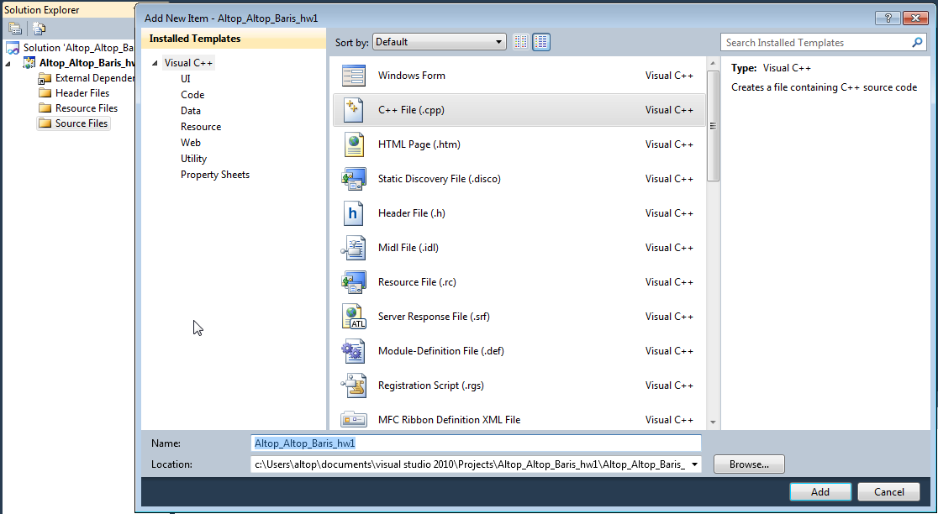

- Your SUCourse user name is actually your SUNet user name which is used for checking sabanciuniv e-mails. Do NOT use any spaces, non-ASCII and Turkish characters in the file name. For example, if your SUCourse user name is cago, name is Çağlayan, and last name is Özbugsızkodyazaroğlu, then the file name must be:

Cago_Ozbugsizkodyazaroglu_Caglayan_hw3.cpp
- Do not add any other character or phrase to the file name.
- Make sure that this file is the latest version of your homework program.
- Compress all .cpp and .h files (including robots and minifw files) in your project using WINZIP or WINRAR programs. Please use "zip" compression. "rar" or another compression mechanism is NOT allowed. Our homework processing system works only with zip files. Therefore, make sure that the resulting compressed file has a zip extension.

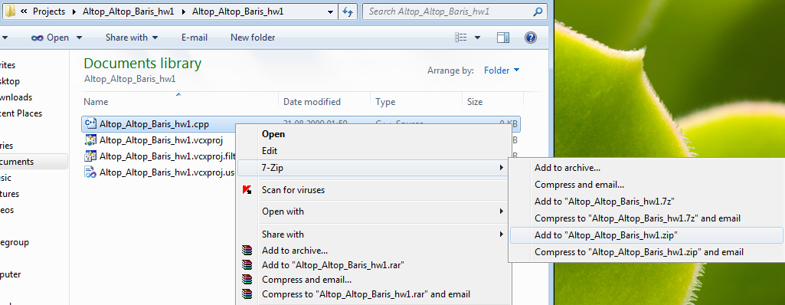

- Check that your compressed file opens up correctly and it contains your cpp file. You will receive no credits if your compressed zip file does not expand or it does not contain the correct file.
- The naming convention of the zip file is the same as the cpp file (except the extension of the file of course). The name of the zip file should be as follows.
“SUCourseUserName_YourLastname_YourName_HWnumber.zip”
For example zubzipler_Zipleroglu_Zubeyir_hw3.zip is a valid name, but hw3_hoz_HasanOz.zip, HasanOzHoz.zip are NOT valid names.

Submission:

- Submit via SUCourse ONLY! You will receive no credits if you submit by other means
(e-mail, paper, etc.).
- Click on "Assignments" at CS201 SUCourse (not the CS201 web site).
- Click Homework 3 in the assignments list.
- Click on "Add Attachments" button.
- Click on "Browse" button and select the zip file that you generated.
- Now, you have to see your zip file in the "Items to attach" list.
- Click on "Continue" button.
- Click on "Submit" button. We cannot see your homework if you do not perform this step even if you upload your file.

Resubmission:

- After submission, you will be able to take your homework back and resubmit. In order to resubmit, follow the following steps.
- Click on "Assignments" at CS201 SUCourse.
- Click Homework 3 in the assignments list.
- Click on "Re-submit" button.
- Click on "Add/remove Attachments" button
- Remove the existing zip file by clicking on "remove" link. This step is very important. If you do not delete the old zip file, we receive both files and the old one may be graded.
- Click on "Browse" button and select the new zip file that you want to resubmit.
- Now, you have to see your new zip file in the "Items to attach" list.
- Click on "Continue" button.
- Click on "Submit" button. We cannot see your homework if you do not perform this step even if you upload your file.

Successful submission is one of the requirements of the homework. If, for some reason, you cannot successfully submit your homework and we cannot grade it, your grade will be 0.

Good Luck!
Ece Egemen and Gülşen Demiröz

Please see the "Input entry and input check" section for the order of input entry and detailed information about the input check and error messages.

